.NET Versions

.NET Framework Version | Exact Version Number | Date of Release | Visual Studio
.NET Framework 1.0 | 1.0.3705.0 | Feb 13, 2002 | Visual Studio .NET
.NET Framework 1.1 | 1.1.4322.573 | April 24, 2003 | Visual Studio .NET 2003
.NET Framework 2.0 | 2.0.50727.42 | November 17, 2005 | Visual Studio 2005
.NET Framework 3.0 | 3.0.4506.30 | November 06, 2006
.NET Framework 3.5 | 3.5.21022.8 | November 19, 2007 | Visual Studio 2008
.NET Framework 4.0 (Beta) |  | October 19, 2009 | Visual Studio 2010 (not yet released completely, but a beta version is available on internet)

Introducing Visual Studio

About Visual Studio:

  - Visual Studio is nothing but the Visual IDE (Integrated Development Environment), which is needed to development applications with .NET Framework.
  - In simple, we can say like “.NET Framework is something that is required to run the .NET applications” and “Visual Studio is something that is required to develop the .NET applications”.

Visual Studio Versions:
  - There are several versions in Visual Studio like Visual Studio 2002, Visual Studio 2003, Visual Studio 2005 and Visual Studio 2008 (as shown in the previous table).

Getting started with Visual Studio:
  - To start with Visual Studio 2008 (the latest version till-to-date), click “Start” – “Programs” – “Microsoft Visual Studio 2008” – “Microsoft Visual Studio 2008”.
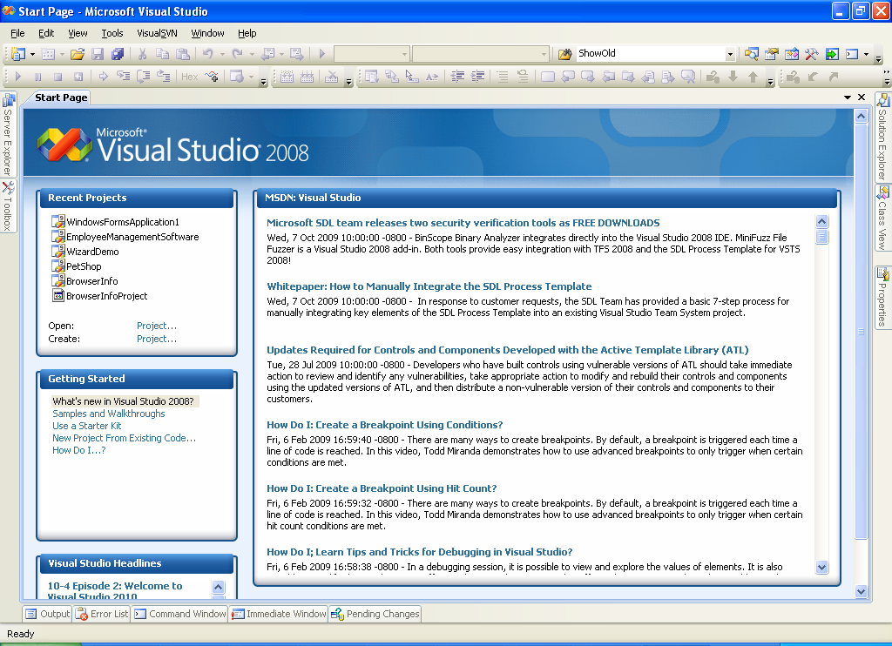

System Requirements of Visual Studio 2005
- Processor:
    - Minimum: P-III
    - Recommended: P-IV (or Higher)
- RAM:
    - Minimum: 192 MB
    - Recommended: 256 MB / 512 MB (or above)

- OS:
    - Microsoft Windows
(2000 / XP / 2003 / Vista / 2008 / Windows 7)
- Hard disk free space:
    - 2.3 GB (on system drive ( C: ))
- CD/DVD Drive:
(For Installation)
- Internet Connection (optional):
(To get latest news from Microsoft’s web site)

System Requirements of Visual Studio 2008

- Processor:
    - Minimum: P-IV
    - Recommended: Higher than P-IV
- RAM:
    - Minimum: 512 MB
    - Recommended: 1 GB (or above)
- OS:
    - MS Windows
(XP / 2003 / Vista / 2008 / Windows 7)
- Hard disk free space:
    - 4.2 GB (on system drive ( C: ))
- CD/DVD Drive
(For Installation)
- Internet Connection (optional)
(To get latest news and updates from Microsoft’s web site)

